In the name of God

Producer:  
Mehrab Atighi

Subject:

Different of Importance sampling M.c

and classical M.c

Date:

12/29/2020

Supervisor:  
Dr.Seyed Noorullah Mousavi

**Issue:** For the computation of the expectation E*f*[*h*(*X*)] when *f* is the  
normal pdf and *h*(*x*) = $exp(-\frac{{\left(x - 3\right)}^{2}}{2}) + exp(-\frac{{\left(x - 6\right)}^{2}}{2})$:  
a. Show that E*f*[*h*(*X*)] can be computed in closed form and derive its value.  
b. Construct a regular Monte Carlo approximation based on a normal *N* (0*,* 1)  
sample of size Nsim=10^3 and produce an error evaluation.  
c. Compare the above with an importance sampling approximation based on  
an importance function *g* corresponding to the *U*(*-*8*, -*1) distribution and  
a sample of size Nsim=10^3. (Warning: This choice of *g* does not provide a  
converging approximation of E*f*[*h*(*X*)]!)

d.do the part c with expontional distrubtion function and show the standard devation,error.

**solve:**

**a)**

We know that if $X\sim N\left(0,1\right),f_{X}\left(x\right)=\frac{1}{\sqrt{2π}}e^{-\frac{x^{2}}{2}} ,and according to the issue we know that:$

$$h\left(x\right)\left(e^{\frac{{\left(x-3\right)}^{2}}{2} }+e^{-\frac{{\left(x-6\right)}^{2}}{2}}\right)$$

$$\int_{-∞}^{∞}{\frac{1}{\sqrt{2π}}e^{-\frac{x^{2}}{2}} \left(e^{\frac{{\left(x-3\right)}^{2}}{2} }+e^{-\frac{{\left(x-6\right)}^{2}}{2}}\right)dx}$$

$$=\int_{-∞}^{∞}{f\left(x\right)h(x)dx\underset{⇒}{M.c}}E_{f}\left[h\left(x\right)\right]$$

Now we want to solve this antegral with close form method:

$$E_{f}\left[\left(x\right)\right]= \int_{-∞}^{∞}{f\left(x\right)h\left(x\right)}=\int_{-∞}^{∞}{\frac{1}{\sqrt{2π}}e^{-\frac{x^{2}}{2}} \left(e^{\frac{{\left(x-3\right)}^{2}}{2} }+e^{-\frac{{\left(x-6\right)}^{2}}{2}}\right)}dx=\int_{-∞}^{∞}{\begin{aligned}e^{-\frac{x^{2}}{2}} \left({\frac{1}{\sqrt{2π}}e}^{\frac{{\left(x-3\right)}^{2}}{2} }+\frac{1}{\sqrt{2π}}e^{-\frac{{\left(x-6\right)}^{2}}{2}}\right) \\ =\end{aligned}}dx$$

$$=\int_{-∞}^{∞}{e^{-\frac{x^{2}}{2}} \left({\frac{1}{\sqrt{2π}}e}^{\frac{{\left(x-3\right)}^{2}}{2} }\right)dx+}\int_{-∞}^{∞}{e^{-\frac{x^{2}}{2}} \left({\frac{1}{\sqrt{2π}}e}^{\frac{{\left(x-6\right)}^{2}}{2} }\right)}dx$$

If we set $g\left(x\right)=e^{-\frac{x^{2}}{2}} ,h_{1}\left(x\right)=\left({\frac{1}{\sqrt{2π}}e}^{\frac{{\left(x-3\right)}^{2}}{2} }\right)=Normal\left(3,1\right) ,h_{2}\left(x\right)=\left({\frac{1}{\sqrt{2π}}e}^{\frac{{\left(x-6\right)}^{2}}{2} }\right)=Normal\left(6,1\right).$

so we have:

$$\int_{-∞}^{∞}{e^{-\frac{x^{2}}{2}} \left({\frac{1}{\sqrt{2π}}e}^{\frac{{\left(x-3\right)}^{2}}{2} }\right)dx=\int_{-∞}^{∞}{g\left(x\right).h_{1}\left(x\right)dx}}$$

$$\int_{-∞}^{∞}{e^{-\frac{x^{2}}{2}} \left({\frac{1}{\sqrt{2π}}e}^{\frac{{\left(x-6\right)}^{2}}{2} }\right)dx=\int_{-∞}^{∞}{g\left(x\right).h_{2}\left(x\right)dx}}$$

We now that the normal distrubtion( $h_{1}\left(x\right),h_{2}(x))$ antegral is 1.

$$\int_{-∞}^{∞}{g\left(x\right).h_{1}\left(x\right)dx}=\int_{-∞}^{∞}{g\left(x\right).1dx}=\int_{-∞}^{∞}{g\left(x\right)dx}$$

$$\int_{-∞}^{∞}{g\left(x\right).h_{2}\left(x\right)dx}=\int_{-∞}^{∞}{g\left(x\right).1dx}=\int_{-∞}^{∞}{g\left(x\right)dx}$$

So we should find the area under the g(x) curve.

$$I=\int_{-∞}^{∞}{g\left(x\right)dx}=\int_{-∞}^{∞}{e^{-\frac{x^{2}}{2}} }dx$$

$I^{2}={\left(\int_{-∞}^{∞}{e^{-\frac{x^{2}}{2}} }dx\right)}^{2}=\left(\int_{-∞}^{∞}{e^{-\frac{x^{2}}{2}} }dx\right)\left(\int_{-∞}^{∞}{e^{-\frac{y^{2}}{2}} }dy\right)$ = $\int_{-∞}^{∞}{\int_{-∞}^{∞}{e^{-\frac{(x^{2}+y^{2})}{2}}}dxdy}$

Now if we set $x=rcos\left(θ\right),y=rsin\left(θ\right) →x^{2}+y^{2}={\left(rcos\left(θ\right)\right)}^{2}+{\left(rsin\left(θ\right)\right)}^{2}$

$$=r^{2}\left(\cos^{2}\left(θ\right)\right)+r^{2}(\sin^{2}{(θ))=}{r^{2}\left(\cos^{2}\left(θ\right)+\sin^{2}\left(θ\right)\right)=r^{2}\left(1\right)=r^{2}}$$

$$\left|j\right|=drdrθ,rdrdθ≈dxdy$$

$$I^{2}=\int_{-∞}^{∞}{\int_{-∞}^{∞}{e^{-\frac{(x^{2}+y^{2})}{2}}}dxdy}=\int_{0}^{2π}{\int_{0}^{∞}{e^{-\frac{r^{2}}{2}}}rdrdθ}$$

If we set $u=-\frac{r^{2}}{2} →du=-rdr$.

$$I^{2}\int_{0}^{2π}{\int_{0}^{∞}{e^{u}}dudθ}\underset{⇔}{*\frac{-1}{-1}} -\int_{0}^{2π}{\int_{0}^{∞}{{-e}^{-u}}dudθ=}-\int_{0}^{2π}{{[-e}^{-u}}]_{0}^{∞} dθ=-\int_{0}^{2π}{[0-(-1)}] dθ$$

$$=\int_{0}^{2π}{dθ}= [θ]_{0}^{2*π}=\left[2π-0\right]=2π$$

So we have:

$$I^{2}=2π →I=\sqrt{2π}$$

$$E_{f}\left[\left(x\right)\right]=\int_{-∞}^{∞}{g\left(x\right).h_{1}\left(x\right)dx}+\int_{-∞}^{∞}{g\left(x\right).h_{2}\left(x\right)dx}=2\int_{-∞}^{∞}{g\left(x\right)dx}=2*\sqrt{2π}$$

**b)**

if we want to use classical monte carlo method for $E_{f}\left[\left(x\right)\right]$ we have:

$$E_{f}\left[\left(x\right)\right]=\int_{-∞}^{∞}{g\left(x\right).h_{1}\left(x\right)dx}+\int_{-∞}^{∞}{g\left(x\right).h_{2}\left(x\right)dx}\underset{⇒}{M.c}E_{h1}\left[g\left(x\right)\right]+E_{h2}\left[g\left(x\right)\right]$$

$$=\lim_{n→∞}{\frac{g(x_{i.h1})}{n}}+\lim_{n→∞}{\frac{g(x_{i.h2})}{n}} for i=1,2,3,…,n$$

Now we can simulate it in R:

> g<-function(x){exp(-(x^2)/2)}

> N=10^3

> H1<-rnorm(N,mean = 3,sd=1)

> H2<-rnorm(N,mean = 6,sd=1)

> E<-(cumsum(g(H1))/1:N)+(cumsum(g(H2))/1:N)

> plot(E , type = "l",col="Blue4")

> abline(h=a , col="850")

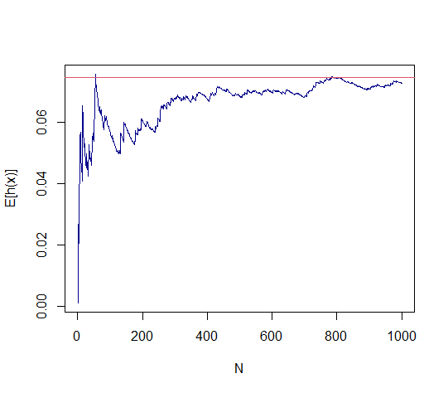

Our estimate for $E_{f}\left[h\left(x\right)\right] is:$

> E[N]

[1] 0.07275448

The real value is:

> a

[1] 0.07453205

Now we can find the our monte carlo estimate error:

> abs(a-E[N])

[1] 0.001777571

now we can find the standard deviation:

> sd(E)

[1] 0.007590212

**c)**

we know that if $U\sim unifrom\left(-8,-1\right),then f_{U}\left(u\right)=\frac{1}{-1-\left(-8\right)}=\frac{1}{7}.$

Now we want to use the Importance sampling Monte carlo .

$$E_{f}\left[\left(x\right)\right]=\int_{-∞}^{∞}{f\left(x\right)h\left(x\right)}dx=\int_{-∞}^{∞}{\frac{f\left(x\right)h\left(x\right)}{g\left(x\right)}}g\left(x\right)dx=E_{g}\left[\frac{f\left(x\right)h\left(x\right)}{g\left(x\right)}\right];$$

According to the question part c we should use $g\left(x\right)=f_{U}(u)$ in our formula, so we have:

$$E_{f}\left[\left(x\right)\right]=\int_{-∞}^{∞}{f\left(x\right)h\left(x\right)}dx=\int_{-∞}^{∞}{\frac{f\left(x\right)h\left(x\right)}{f\left(u\right)}}f\left(u\right)dx=\int_{-8}^{-1}{\frac{1}{\sqrt{2π}}e^{-\frac{x^{2}}{2}} \left(e^{\frac{{\left(x-3\right)}^{2}}{2} }+e^{-\frac{{\left(x-6\right)}^{2}}{2}}\right)*\frac{7}{7}dx}$$

$$=7\int_{-8}^{-1}{\frac{\left[\frac{1}{\sqrt{2π}}e^{-\frac{x^{2}}{2}} \left(e^{\frac{{\left(x-3\right)}^{2}}{2} }+e^{-\frac{{\left(x-6\right)}^{2}}{2}}\right)\right]}{7} dx}$$

$$=7\int_{-8}^{-1}{\frac{\left[e^{-\frac{x^{2}}{2}} \left({\frac{1}{\sqrt{2π}}e}^{\frac{{\left(x-3\right)}^{2}}{2} }\right)\right]}{7}dx+}7\int_{-8}^{-1}{\frac{\left[e^{-\frac{x^{2}}{2}} \left({\frac{1}{\sqrt{2π}}e}^{\frac{{\left(x-6\right)}^{2}}{2} }\right)\right]}{7}dx \underset{⇒}{M.c}7E_{u}\left[\frac{f\left(u\right)h_{1}\left(u\right)}{f\left(u\right)}\right]+}7E_{u}\left[\frac{f\left(u\right)h_{2}\left(u\right)}{f\left(u\right)}\right]$$

So now we can simulate it in R:

> N=10^3

> G1<-function(x){exp(-(x^2)/2)*exp(-1/2*(x-3)^2)/(sqrt(2*pi))}

> G2<-function(x){exp(-(x^2)/2)*exp(-1/2*(x-6)^2)/(sqrt(2*pi))}

> G<-integrate(G1,-8,-1)$val+integrate(G2,-8,-1)$val

> u<-runif(N,min=-8,max=-1)

> g1<-function(x){exp(-(x^2)/2)*exp(-1/2*(x-3)^2)/(7*sqrt(2*pi))}

> g2<-function(x){exp(-(x^2)/2)*exp(-1/2*(x-6)^2)/(7*sqrt(2*pi))}

> R<-7*((cumsum(g1(u))/1:N)+(cumsum(g2(u))/1:N))

> plot(R, type = "l" , ylim =c(min(R),G), xlab="N" , ylab = "E[h(u)f(u)/f(u)]")

> abline(h=G ,col="Blue")

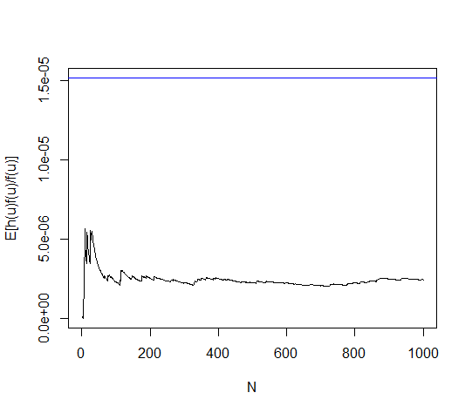

Our estimate for $7E_{u}\left[\frac{f\left(u\right)h_{1}\left(u\right)}{f\left(u\right)}\right]+7E_{u}\left[\frac{f\left(u\right)h_{2}\left(u\right)}{f\left(u\right)}\right] is:$

> R[N]

[1] 2.449683e-06

The real value is:

> G

[1] 1.516476e-05

Now we can find the our monte carlo estimate error:

> abs(G-R[N])

[1] 1.271508e-05

now we can find the standard deviation:

> sd(R)

[1] 4.939516e-07

**d)**

we know that if $P\sim E\left(λ\right),f_{P}\left(p\right)=\frac{1}{λ}e^{-\frac{x}{λ}}$

the importance sampling minte carlo method formula is:

$$E_{f}\left[\left(x\right)\right]=\int_{-∞}^{∞}{f\left(x\right)h\left(x\right)}dx=\int_{-∞}^{∞}{\frac{f\left(x\right)h\left(x\right)}{g\left(x\right)}}g\left(x\right)dx=E_{g}\left[\frac{f\left(x\right)h\left(x\right)}{g\left(x\right)}\right];$$

According to our qurstion pard d, we should set the $g\left(x\right)=f_{P}(p)$.so we have:

$$E_{f}\left[\left(x\right)\right]=\int_{-∞}^{∞}{f\left(x\right)h\left(x\right)}dx=\int_{-∞}^{∞}{\frac{f\left(x\right)h\left(x\right)}{f\left(u\right)}}f\left(u\right)dx =\int_{0}^{∞}{\frac{1}{\sqrt{2π}}e^{-\frac{x^{2}}{2}} \left(e^{\frac{{\left(x-3\right)}^{2}}{2} }+e^{-\frac{{\left(x-6\right)}^{2}}{2}}\right)*\frac{\frac{1}{λ}e^{-\frac{x}{λ}}}{\frac{1}{λ}e^{-\frac{x}{λ}}}dx}$$

$$\int_{0}^{∞}{\frac{\left[e^{-\frac{x^{2}}{2}} \left({\frac{1}{\sqrt{2π}}e}^{\frac{{\left(x-3\right)}^{2}}{2} }\right)\right]}{\frac{1}{λ}e^{-\frac{x}{λ}}}\frac{1}{λ}e^{-\frac{x}{λ}}dx+}\int_{0}^{∞}{\frac{\left[e^{-\frac{x^{2}}{2}} \left({\frac{1}{\sqrt{2π}}e}^{\frac{{\left(x-6\right)}^{2}}{2} }\right)\right]}{\frac{1}{λ}e^{-\frac{x}{λ}}}\frac{1}{λ}e^{-\frac{x}{λ}}dx \underset{⇒}{M.c}E_{u}\left[\frac{f\left(p\right)h_{1}\left(p\right)}{f\left(p\right)}\right]+}E_{u}\left[\frac{f\left(p\right)h_{2}\left(p\right)}{f\left(p\right)}\right]$$

Now we simulate in R:(here we set $λ=1)$

> N=10^3

> F1<-function(x){exp(-(x^2)/2)*exp(-1/2*(x-3)^2)/(sqrt(2*pi))}

> F2<-function(x){exp(-(x^2)/2)*exp(-1/2*(x-6)^2)/(sqrt(2*pi))}

> F<-integrate(F1,0,Inf)$val+integrate(F2,0,Inf)$val

> q<-rexp(N,rate =1)

> f1<-function(x){(1/exp(-x/2))*exp(-(x^2)/2)*exp(-1/2*(x-3)^2)/(sqrt(2*pi))}

> f2<-function(x){(1/exp(-x/2))*exp(-(x^2)/2)*exp(-1/2*(x-6)^2)/(sqrt(2*pi))}

> W<-((cumsum(f1(q))/1:N)+(cumsum(f2(q))/1:N))

> plot(W, type = "l" , ylim =c(min(W),F))

> abline(h=F,col="Blue")

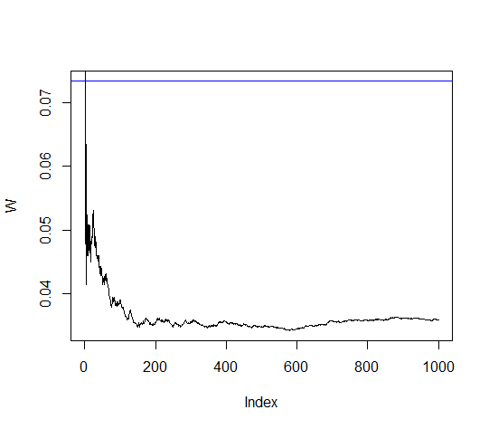

Our estimate for $E_{u}\left[\frac{f\left(p\right)h_{1}\left(p\right)}{f\left(p\right)}\right]+E_{u}\left[\frac{f\left(p\right)h_{2}\left(p\right)}{f\left(p\right)}\right]$

> W[N]

[1] 0.03597266

The real value is:

> F

[1] 0.07335276

Now we can find the our monte carlo estimate error:

> abs(F-W[N])

[1] 0.0373801

now we can find the standard deviation:

> sd(W)

[1] 0.003373489

End.